QUESTION NO 1  
  
  
  
include irvine32.inc

.data

v1 DW 1250

v2 DW 9830

.code

main PROC

mov ax, v1

mov bx, v2

div bx

call DumpRegs

exit

main ENDP

end main



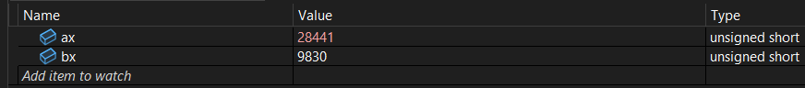

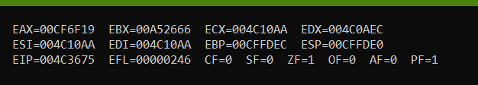

QUESTION NO 2

include irvine32.inc

.data

arr DW 1250,3456,9876,7654

typ DW ?

siz DW ?

len DW ?

.code

main PROC

mov ax,type arr

mov bx,sizeof arr

mov cx, lengthof arr

mov typ, ax

mov siz, bx

mov len, cx

call DumpRegs

exit

main ENDP

end main

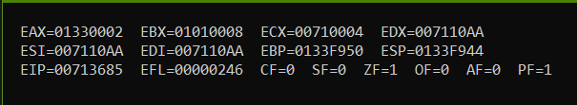

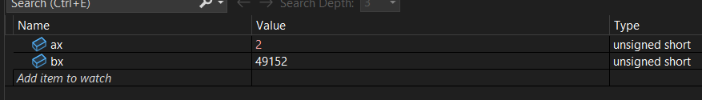



QUESTION NO 3

include irvine32.inc

.data

arr1 DW 1250h,3456h,9876h,7654h

arr2 DB 50h,36h,96h,74h

arr3 DD 11332350h,34235336h,98333376h,55557654h

typ1 DW ?

siz1 DW ?

len1 DW ?

typ2 DB ?

siz2 DB ?

len2 DB ?

typ3 DD ?

siz3 DD ?

len3 DD ?

address1 DD ?

address2 DD ?

address3 DD ?

.code

main PROC

mov ax,type arr1

mov bx,sizeof arr1

mov cx, lengthof arr1

mov typ1, ax

mov siz1, bx

mov len1, cx

;-----------------------------

mov al, type arr2

mov bl, sizeof arr2

mov cl, lengthof arr2

mov typ2, al

mov siz2, bl

mov len2, cl

;----------------------------

mov eax, type arr3

mov ebx, sizeof arr3

mov ecx, lengthof arr3

mov typ3, eax

mov siz3, ebx

mov len3, ecx

;----------------------------

mov esi, offset arr1

mov address1,esi

mov esi, offset arr2

mov address2,esi

mov esi, offset arr3

mov address3,esi

call DumpRegs

exit

main ENDP

end main

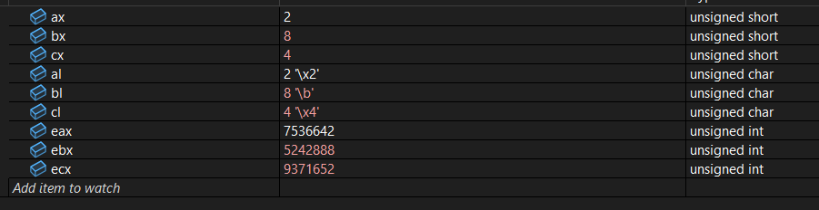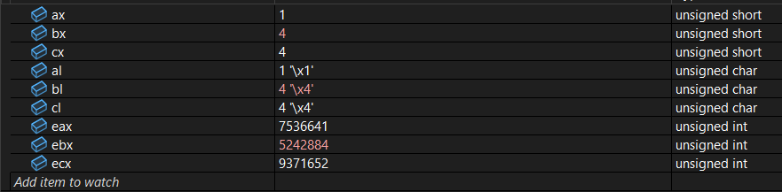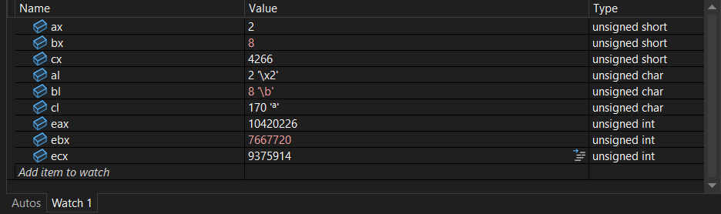

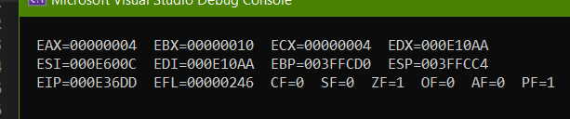

QUESTION NO 5

include irvine32.inc

.data

num DWORD 12345678h

result WORD ?

.code

main PROC

mov al, BYTE PTR num

mov bl, al

mov al, BYTE PTR num+3

mov bh, al

mov al, bl

mul bh

mov result, ax

Done:

call DumpRegs

exit

main ENDP

end main

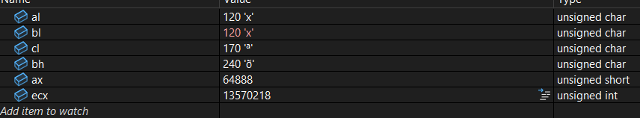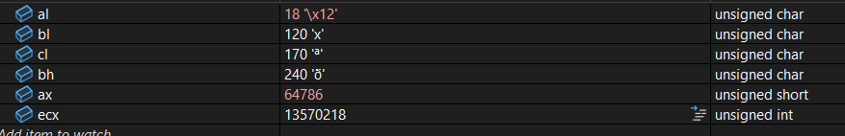

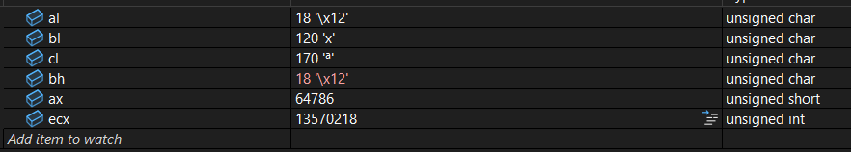

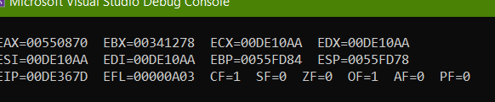

QUESTION NO 7

include irvine32.inc

.data

val1 BYTE 10110100b

.code

main PROC

mov al, val1

and al, 11110000b

call DumpRegs

or al, 00001111b

call DumpRegs

exit

main ENDP

end main

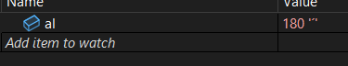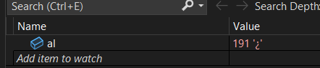

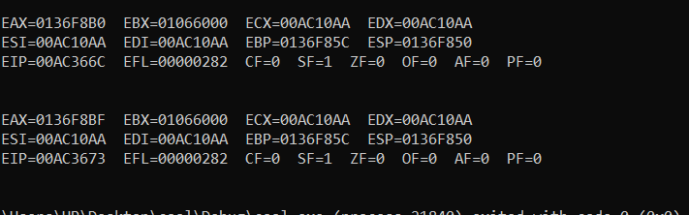

QUESTION NO 6

include irvine32.inc

.data

num DWORD 12345478h

quot WORD ?

remain WORD ?

.code

main PROC

mov ax, WORD PTR num+2

mov bl, BYTE PTR num

xor dx, dx

div bl

mov quot, ax

mov remain, dx

call DumpRegs

exit

main ENDP

end main

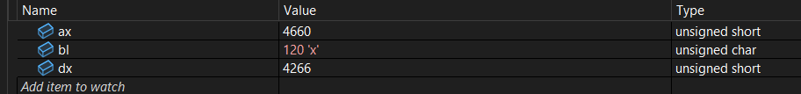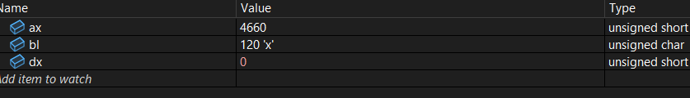

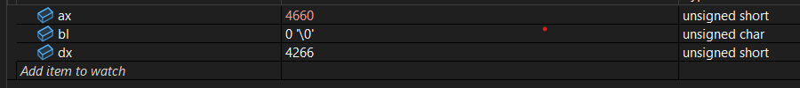

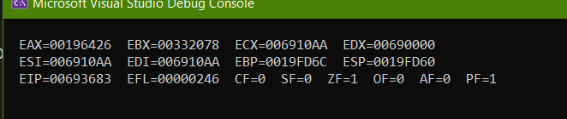

QUESTION NO 8

include irvine32.inc

.data

a BYTE 00010101b

b BYTE 11110000b

.code

main PROC

; --- Flip all bits IN a ---

mov al, a

not al ; AL = NOT(00010101b) = 11101010b

mov a, al

; --------- Swap a and b using XOR ------------------

mov al, a

mov bl, b

xor al, bl

xor bl, al

xor al, bl

; store swapped values

mov a, al

mov b, bl

call DumpRegs

exit

main ENDP

end main

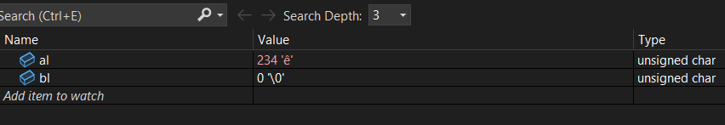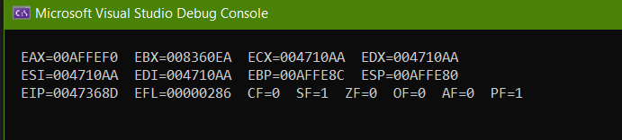

QUESTION NO 4

include irvine32.inc

.data

arr DB 24h, 93h , 22h, 54h

result WORD ?

.code

main PROC

mov al, BYTE PTR arr+1

mov bl, 3

add al, bl

mov al, BYTE PTR arr+3 ;54

mov bl, 3

add al, bl

Done:

call DumpRegs

exit

main ENDP

end main

